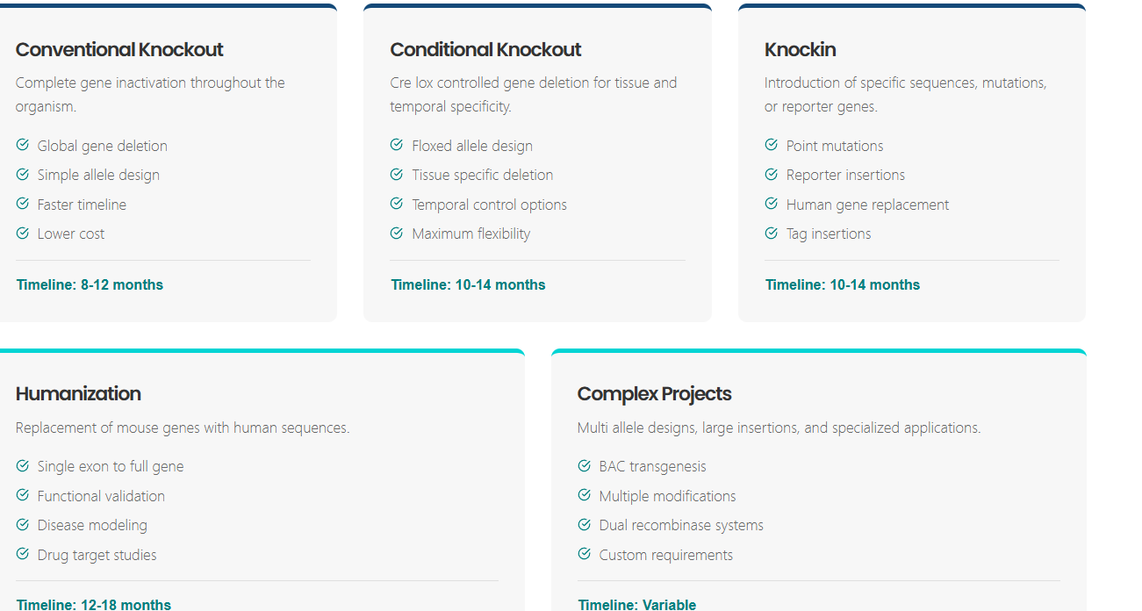

Need to remove Timelines from each

Please remove the following section Custom Project Workflow and What You Will Receive

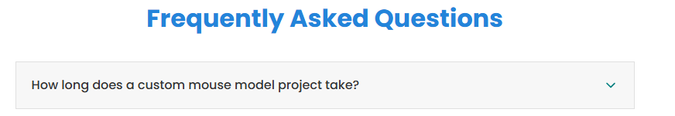

Please remove How long does a custom mouse model project take

There is no link to Knockout Strategy Guide

Please remove Model Generation Timeline

Please remove Pricing Overview
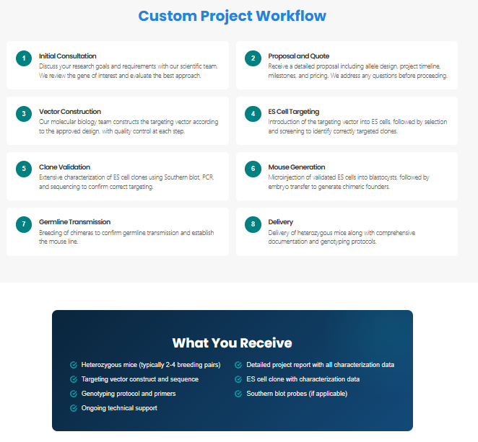

Custom

